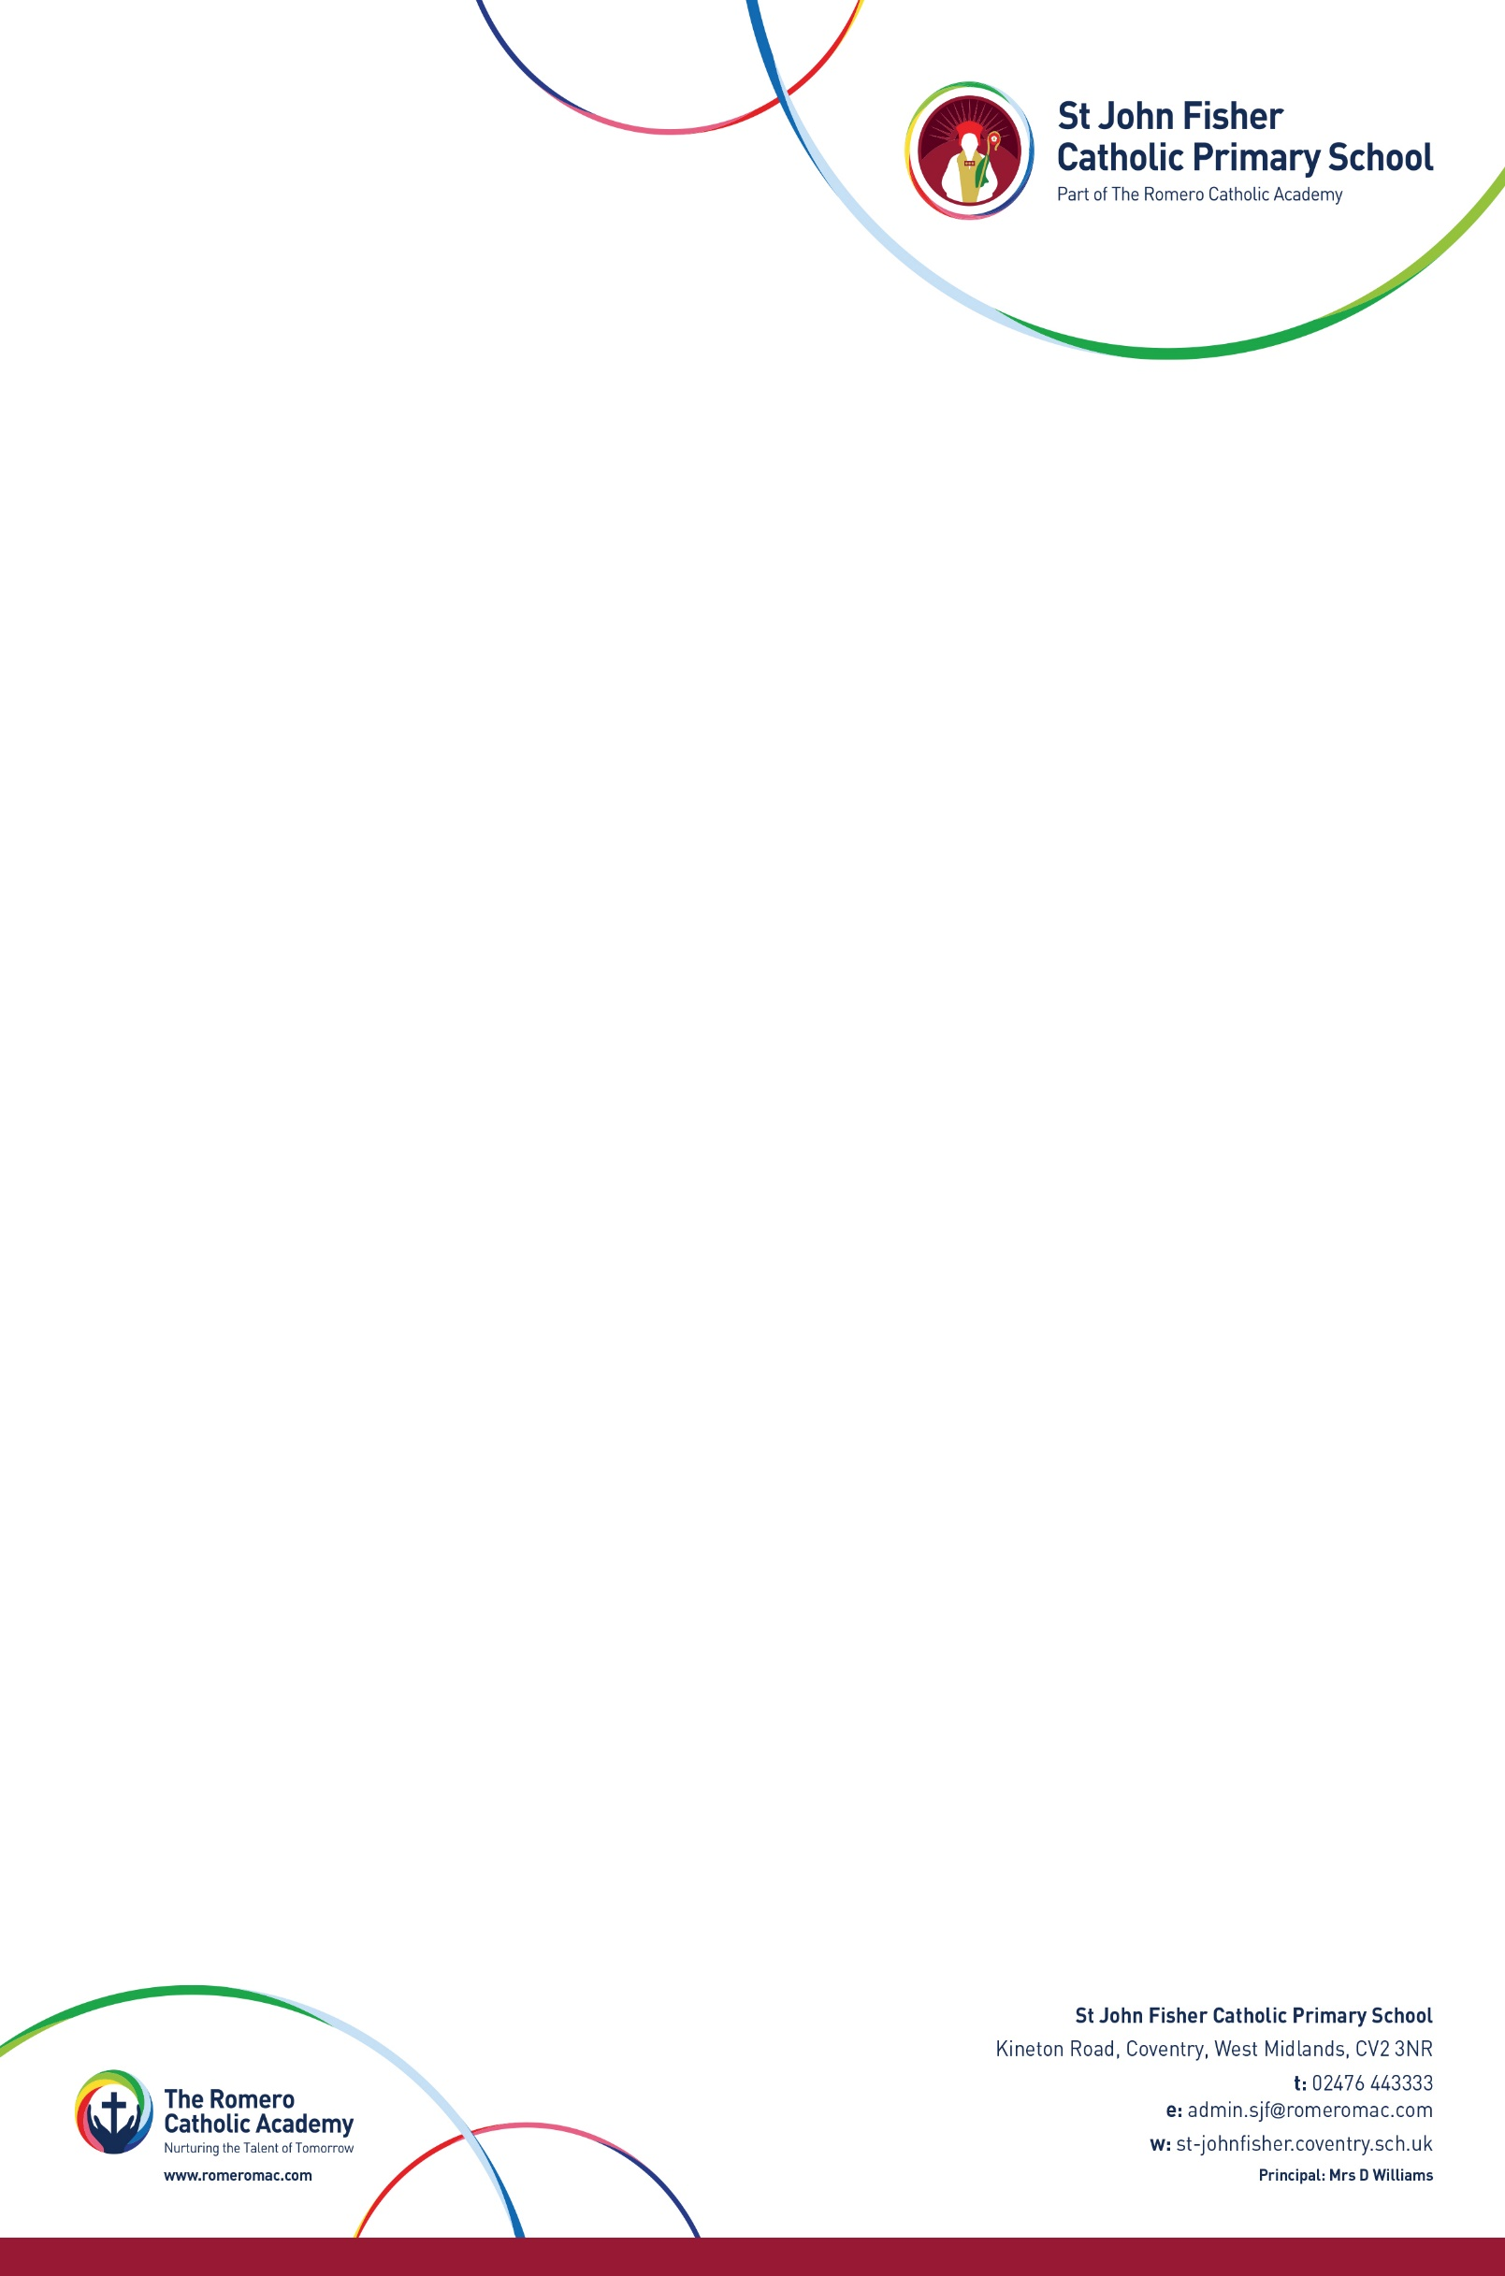

**NURSERY APPLICATION FORM SEPTEMBER 2020 DOB between 1stSeptember 2016 to 31st August 2017**

Childs Name ……………………………………………………………………………………………………………………………… Date of Birth ………………………………………………………………

Address ………………………………………………………………………………………………………………….…………………… Post Code ….………………………………………………………………...

Mobile Number …………………………………………………………………………..… 2nd Contact Number ……………………………………………………………………………………….…

Catholic Baptism Date and Church ………………………………………………………………………………………………Contact Email………………………………………………………….

Names of Brothers/Sisters attending St John Fisher Catholic Primary School……………………………………………………………………………………………………………………………………………………………

Position in Family …………………………………………………… Previous Nursery/Preschool ……………………………………………………………………………………………………

Name of Mother …………………………………………………………………… Name of Father..…………………………………………………………………………………………………………….

PLEASE TICK YOUR SESSION PREFERENCE

MORNING 8:30am to 11:30am  Monday to Friday

AFTERNOON 12.30pm to 3.30pm  Monday to Friday

ALL DAY 8.30pm to 3.30pm  Monday to Friday

National Insurance Number ……………………………………..… Have you checked your eligibility at www.childcarechoices.gov.uk

I require 15 Hours Universal Entitlement  Parent Date of Birth who claimed the code ………………………..………

I am eligible to 30 Hours Extended Entitlement 

Signed By …………………………………………………………………………………………………………………………. Date ………………………………………………………………………………………………………………………………….

A child who attends St John Fisher Nursery is not guaranteed a Reception Class place. Parents must follow the admissions process under the Local Authority procedures.