**Spring Term: 7th February 2020**

**‘Through Christ we live, love and learn in our caring community.’**

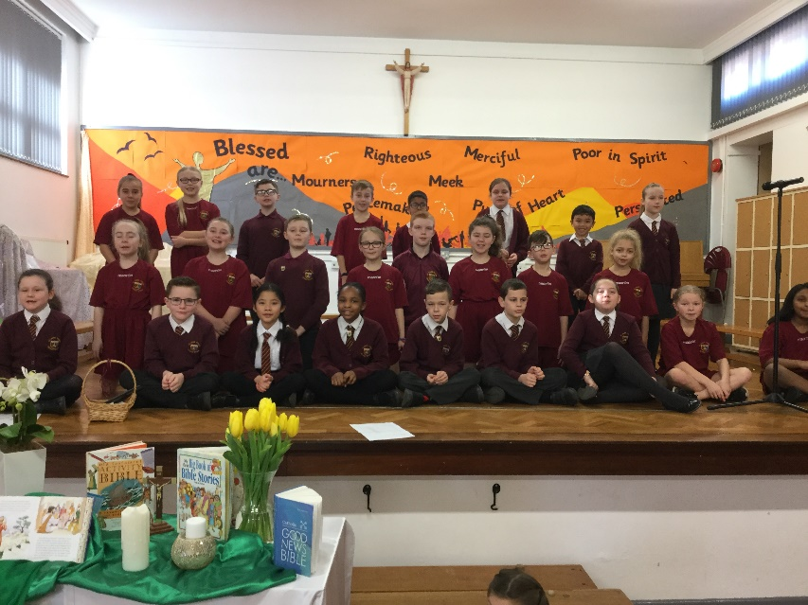**News This Week**

Thank you to Class 12 (Year 5) for leading our Parent’s Assembly this morning. The children reminded us how we should work together as a team and that love is the thing that can hold us together.

**Value and Virtue for this ½ term**

**Compassionate and Loving**

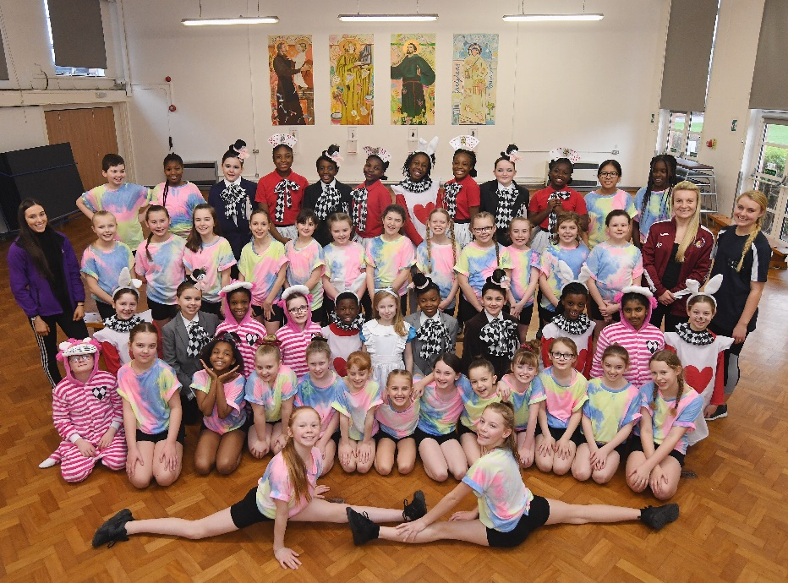

**Great British Dance Off**

Congratulations to dance club for their phenomenal performance on Monday at the Alexandra Theatre in Birmingham. Their hard-work and dedication paid off with them placing 3rd out of 16 qualifying schools from the west midlands region and qualifying them to compete in the National Finals in June this year! We are very proud of you all! Here are some photos from our dress rehearsal last Friday.

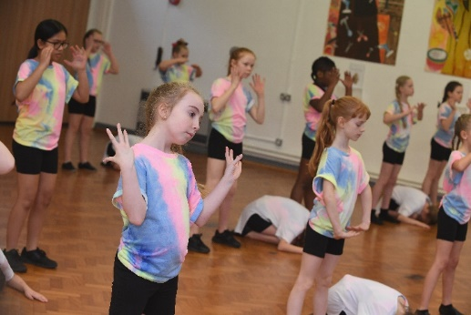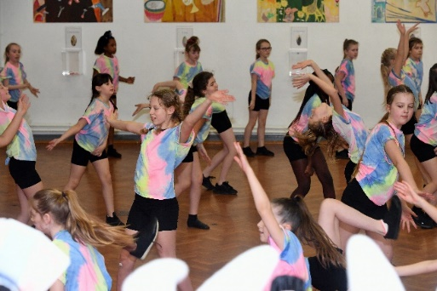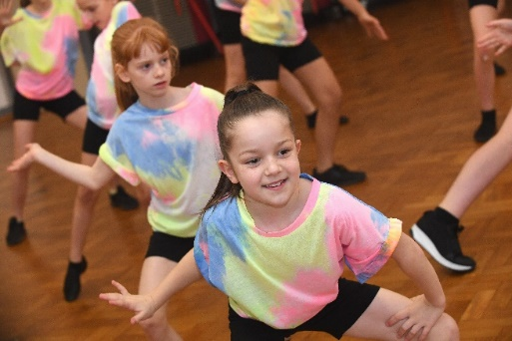

**Gifted and Talented Library Quiz**

This week Damola, Oyinkansola, Jonjo and Mariam competed in the Coventry City Library quiz. For the quiz they needed to read 3 books in detail and be able to answer questions on them. They also needed a good general book knowledge. Their heat was held at Bell Green Library on Tuesday afternoon. St John Fisher secured their place in the city wide final by being the highest scoring runners up of the day, missing winning their heat by just half a mark! We are very proud of you and cannot wait to see how you do in the final.

**Football Match**

SJF got off to a great start on Wednesday beating St Lawrence 3-0 in the Harry Shaw Plate seeing SJF progress to the next round - a great team performance.

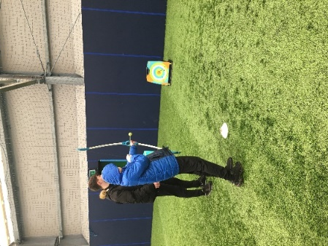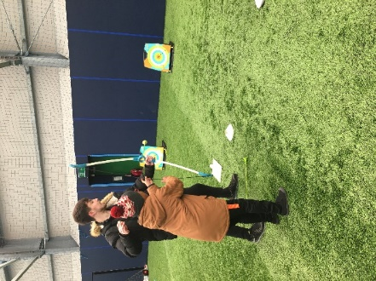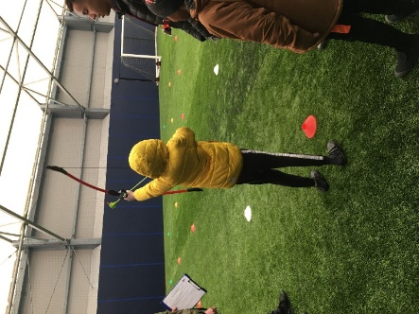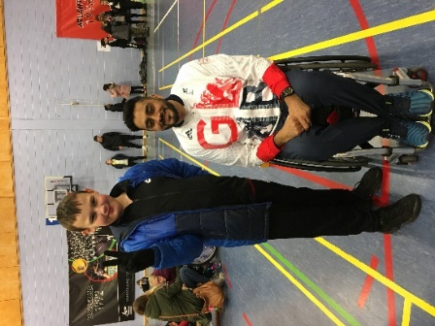**Archery Practice**

Some of our children had the opportunity to practice their archery skills today at Alan Higgs.

**Let’s Walk to school:** Travel Tracker - We are delighted that many of our children have been awarded with their first badges for walking, cycling or riding a scooter to school at least once every week in January.Class 6 were awarded 10 badges, Class 9 were awarded 17 badges, Class 11 were awarded 25 badges and Class 12 were awarded 23 badges. This month the badge featured a steam engine.

**Reception and KS1 absolutely love their new climbing wall!**

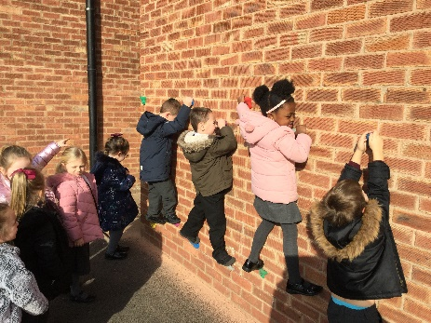

**Star of the Week: See who has shone this week!**

|  |  |  |  |
| --- | --- | --- | --- |
| **YR: Mrs Mills/Mrs Smith** | **Lilly-Rose**  **Isabella** | **Y3: Mrs Smith/Mrs Taylor** | **Daisy-Mae**  **Archie** |
| **YR: Miss Mullen** | **Lukas**  **Imaan** | **Y4: Miss Watson** | **Teddy** |
|  |  |  | **Lexi McMc** |
| **Y1: Miss Malik** | **Aidan**  **Lexie** | **Y4: Miss Jarvis** | **Jack M** |
|  |  |  | **Jakub** |
| **Y1: Miss Burton** | **Abel**  **Brahmveer** | **Y5: Mrs Edge/Mrs Finn** | **Danny**  **Christopher**  **Damola** |
|  |  |  |  |
| **Y2: Miss Cunningham** | **Orla** | **Y5: Mrs Davies** | **Whole Class** |
|  | **Roxanne** |  |  |
| **Y2: Mrs Corry** | **Courtnie** | **Y6: Mrs Pelchat** | **Leison** |
|  | **Teagan** |  | **Kiernan** |
| **Y3: Miss Stephens** | **Daisy**  **Kira** | **Y6: Mr Morris** | **Wiktoria**  **Samuel** |
|  |  |  |  |

**Attendance**

|  |  |  |  |  |  |  |
| --- | --- | --- | --- | --- | --- | --- |
| **Year** | **Class** | **Teacher** | **Attendance** | **Class** | **Teacher** | **Attendance** |
| Reception | **1** | **Mrs Mills/Mrs Smith** | 100% | **2** | **Miss Mullen** | 91.23% |
| Year 1 | **3** | **Miss Malik** | 95.42% | **4** | **Miss Burton** | 89.17% |
| Year 2 | **5** | **Miss Cunningham** | 99.14% | **6** | **Mrs Corry** | 97.08% |
| Year 3 | **7** | **Miss Stephens** | 93.53% | **8** | **Mrs Taylor/Mrs Smith** | 100% |
| Year 4 | **9** | **Miss Watson** | 99.14% | **10** | **Miss Jarvis** | 94.58% |
| Year 5 | **11** | **MrsEdge/Mrs Finn** | 98.75% | **12** | **Mrs Davies** | 90.83% |
| Year 6 | **13** | **Mrs Pelchat** | 99.17% | **14** | **Mr Morris** | 90.42% |

**House Points:**

**341 255 269 242 158**

**Looking for sponsors our production:** We need your help! We have an exciting opportunity for a limited number of small businesses to sponsor our end of year production at the Albany Theatre.

Sponsoring the show will enable us to once again give our year 6 children the once-in-a-lifetime opportunity to experience being part of a production on a professional stage. Our year 5 children also support this fantastic night of entertainment and the whole school are invited to attend a performance.

We are asking for a sponsorship fee of £100 and can offer our sponsors the following:

* A full page colour advert in the production programme.
* Two VIP tickets to the production, with seats on the first two rows at the theatre.
* A personalised thank-you by Mrs. Williams following the show, recognition on our newsletter and social media.
* A framed cast photo, featuring company logo and school badge, for display at your workplace.

If you are a small business owner or work for/know of a business that would be interested in supporting us in this way, please let us know by 28th February 2020 and we will be in touch.

**Did you attend Cardinal Wiseman School, Coventry?**

We have a group called **The Wiseman** **Connection** where you can reconnect with old friends, tell us about where life has taken you since leaving school or help to get involved with the school today.

Look for us on **The Cardinal Wiseman** website (part of The Romero Catholic Academy) where you can register to become a member of The Wiseman Connection.

We are also on:

* **Facebook** at **The Wiseman Connection** (a closed group within The Romero Catholic

Academy page)

* **Twitter** at **@WisemanCardinal**
* **Linked In** at **The Wiseman Connection** site.

Come and join us and look out for future events and become involved in your Wiseman Connection.

Contact Admin.TWC@romeromac.com for further details.



***Dates for week beginning 10th February 2020***

**Tuesday 11th February Choir and Dance – CWI – Got talent**

**Wednesday 12th February Swimming Gala**

**Thursday 13th February - Year 3 Highly Sprung Project – Think Tank in Birmingham**

**Thursday 13th February - KS2 - Valentine Disco in KS2 Hall- 5.30pm- 7.00pm**

***Have a lovely weekend!***

**Mrs D Williams**

**Principal**